The Implementation of South Korea-Indonesia Defense Diplomacy in the Shifting Defense Industrial Cooperation in the Chang Bogo-Class Submarine Project 2019-2023

Joodael Kim¹, Frega F. Wenas Inkiriwang ², Anak Agung Banyu Perwita³

1Indonesian Defence University, Bogor, Indonesia
2 Indonesian Defence University, Bogor, Indonesia
3 Indonesian Defence University, Bogor, Indonesia

Dreakim12@gmail.com, frega.wenas@idu..ac.id ,aabanyu.perwita@gmail.com

Abstract
This study examines the dynamic of South Korea-Indonesia defense industrial cooperation from 2019 to 2023, focusing on the Chang Bogo-class submarine project. The research is motivated by shifts in defense priorities between the Yudhoyono and Jokowi administrations, particularly regarding modernization, economic resilience, and budget efficiency. While the Yudhoyono government emphasized joint production and technology transfer, the Jokowi administration's focus on fiscal constraints led to adjustments in the scale and pace of collaboration. This study aims to analyze these shifts and their impact on bilateral defense relations. To achieve this, five theoretical frameworks—International Relations Theories, Foreign Policy, Defense Policy, Defense Diplomacy, and Defense Industry—are applied to provide a comprehensive evaluation. The research employs policy reviews, case studies, and analyses of defense agreements and official reports to assess the underlying factors influencing cooperation. The findings indicate that economic limitations, evolving foreign policy goals, and differing leadership approaches have affected project progress. However, sustained defense diplomacy, including high-level meetings and strengthened agreements, has helped maintain collaboration despite these challenges. The study concludes that aligning defense cooperation with political and economic realities is essential for sustainability. Recommendations include improving financial strategies in joint projects, implementing phased technology transfer, and strengthening institutional frameworks to ensure long-term defense partnerships. By addressing these areas, South Korea and Indonesia can enhance their defense collaboration, contributing to regional security and capability development. This research highlights the importance of adaptive defense diplomacy in maintaining strategic partnerships amid shifting national priorities.
Keywords: Defense Diplomacy, South Korea-Indonesia, Chang Bogo-Class Submarine

This work is licensed under a Creative Commons Attribution-ShareAlike 4.0 International License.

INTRODUCTION
South Korea and Indonesia have developed a strategic defense partnership over the years, with their defense industrial cooperation evolving significantly. The Chang Bogo-Class Submarine Project represents a key initiative within this bilateral defense relationship. Initially established through the 1995 Defense and Military Supplies Cooperation Memorandum of Understanding (MOU), this collaboration expanded in the early 2000s with major arms exports, including the KT-1 training aircraft and T-50 Golden Eagle jet trainers (Al-Fadhat, 2019). Indonesia's introduction of the Minimum Essential Force (MEF) strategy in 2010 further deepened this cooperation, focusing on joint defense development and reducing reliance on foreign arms imports (Kim, 2012). South Korea's involvement became even more significant with projects such as the KF-X/IF-X fighter jet program in 2010 and the Chang Bogo-Class Submarine Batch-I in 2011, both of which included technology transfers and joint production (Korea Institute for Defense Analyses, 2020). However, since 2019, Indonesia’s shifting defense priorities under the Jokowi administration have led to delays and reevaluations in the Chang Bogo Batch-II submarine agreement. Budget constraints, policy adjustments, and strategic realignments have affected the pace of cooperation, raising concerns about the sustainability of their defense partnership (SIPRI, 2024). This research examines how these strategic shifts between 2019 and 2023 have impacted the Chang Bogo-Class Submarine Project, highlighting the role of defense diplomacy, economic constraints, and geopolitical considerations in shaping bilateral defense industrial cooperation.
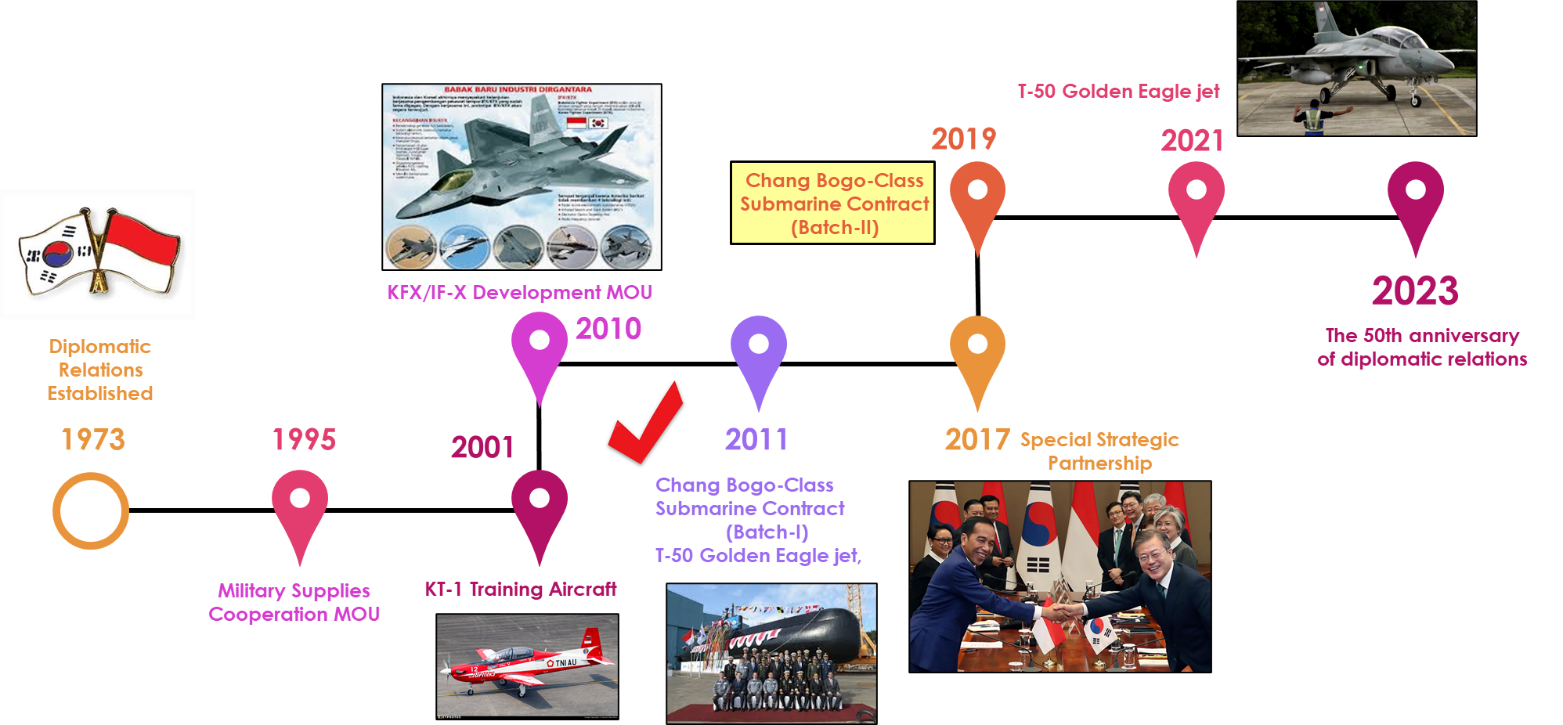
Fig. 1 Timeline of Relation between Indonesia – South Korea
Source: Adopted by the author from previous research, 2024
Despite the long-standing defense relationship between South Korea and Indonesia, the period between 2019 and 2023 witnessed a decline in new defense projects and delays in ongoing initiatives (Korea Institute for International Economic Policy, 2022).
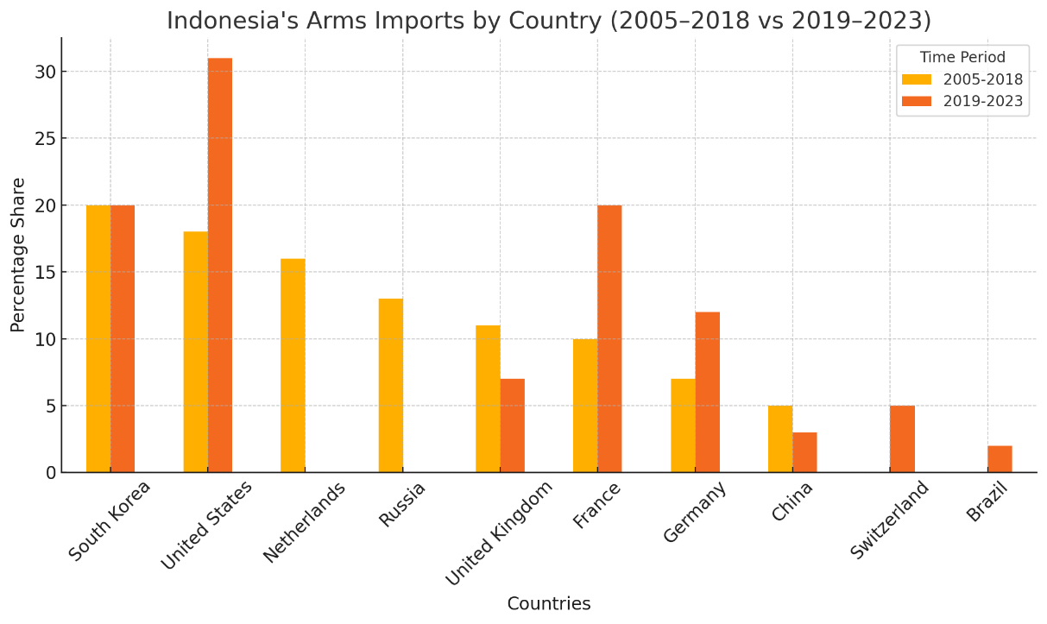
Fig. 2 Changes in Indonesia's Major Arms Trading Partners

This study aims to analyze the impact of South Korea-Indonesia defense diplomacy on the Chang Bogo-Class Submarine Project during this period and examine the economic, political, and strategic factors contributing to the delays and modifications in the cooperation agreement. Furthermore, it seeks to assess the effectiveness of bilateral diplomatic engagements in sustaining defense cooperation despite these challenges. By addressing these issues, the research attempts to answer how the shifts in defense diplomacy between the two nations have influenced defense industrial cooperation, particularly regarding the Chang Bogo-Class Submarine Project, and how both countries have adapted their defense diplomacy strategies to mitigate the challenges affecting the project (Tamarell et al., 2023).
Grounded in International Relations and Defense Diplomacy theories, this study focuses on defense industrial cooperation as a tool for national security and economic growth (Cottey & Forster, 2004). Existing literature provides insights into economic and political determinants of defense cooperation (Manafe et al., 2020), comparative case studies on defense industrial partnerships—such as the India-Russia BrahMos missile cooperation and the Brazil-Sweden Gripen fighter jet program (Rocha, 2019)—and challenges in technology transfer and defense diplomacy, particularly in military-industrial strategies of developing countries (Indonesia Ministry of Defense, 2021). By integrating these perspectives, this research offers a comprehensive analysis of South Korea-Indonesia defense industrial cooperation within a changing geopolitical landscape.
The significance of this study lies in both its academic contributions and practical implications. Theoretically, it advances the understanding of how defense diplomacy shapes industrial cooperation, particularly within Southeast Asia’s evolving security environment. Practically, it provides policy recommendations for strengthening South Korea-Indonesia defense cooperation, ensuring more effective negotiation strategies, technology transfers, and joint production agreements. As regional and global defense landscapes continue to shift, this research underscores the critical role of diplomatic engagement in maintaining and enhancing long-term military-industrial partnerships (Magnuson, 2023).

METHODOLOGY
This research utilizes a qualitative case study approach to examine the shifts in South Korea-Indonesia defense industrial cooperation between 2019 and 2023, with a particular focus on the Chang Bogo-Class Submarine Project. To achieve a comprehensive analysis, data collection is conducted through multiple sources, including interviews, document analysis, data repositories, and media reports.
Interviews are conducted with government officials, defense industry experts from PT PAL and Hanwha Ocean, and academics specializing in defense diplomacy. These interviews provide firsthand insights into policy decisions, industrial challenges, and diplomatic strategies shaping bilateral defense cooperation.
Document analysis includes reviewing defense agreements, white papers, and policy reports published by institutions such as the Indonesia Ministry of Defense (2021). These documents offer essential context for understanding the historical evolution and current state of defense cooperation.
Data repositories, such as the SIPRI Arms Transfers Database (2024), are used to analyze arms trade trends between South Korea and Indonesia. This provides empirical evidence of changes in defense industrial cooperation, particularly in arms imports, exports, and production agreements.
Additionally, media reports are examined to assess public narratives and perceptions regarding defense cooperation. This analysis highlights how geopolitical events, policy decisions, and diplomatic engagements are portrayed in the public sphere, influencing defense collaboration.
To process and interpret the collected data, various analytical methods are employed. Thematic analysis (Braun & Clarke, 2006) is used to identify key themes and patterns within qualitative data, while content analysis (Krippendorff, 2013) is applied to systematically evaluate defense-related documents and agreements. Trend analysis (SIPRI, 2024) is conducted to examine shifts in defense trade statistics over time, offering insights into evolving defense relationships. Additionally, comparative analysis is utilized to contrast defense cooperation trends before and after 2019, and a case study analysis (Yin, 2018) is performed to explore the Chang Bogo-Class Submarine Project in detail.

RESULT
This study examines shifts in South Korea-Indonesia defense diplomacy (2019-2023) and their impact on defense industrial cooperation, particularly the Chang Bogo-Class Submarine Project. While Batch-I (2011) progressed smoothly with successful technology transfer (ToT) and joint production, Batch-II (2019) faced delays due to financial constraints, shifting national priorities, and strategic realignments. This study highlights how diplomatic strategies, economic pressures, and geopolitical changes shaped bilateral defense cooperation.
3.1 The informants' data collection results
Collection results were structured into five key areas based on the theoretical framework. In terms of national interests, South Korea prioritizes defense exports, regional stability, and economic partnerships, with projects like the Chang Bogo-Class Submarine playing a significant role. Meanwhile, Indonesia focuses on maritime sovereignty, military modernization, and technology transfer to enhance its domestic defense capabilities. Regarding foreign policy, South Korea’s New Southern Policy aims to strengthen ASEAN partnerships through economic, security, and diplomatic engagement, while Indonesia adheres to a Free and Active Foreign Policy, emphasizing strategic autonomy while balancing partnerships with multiple defense suppliers.
In terms of defense policy, South Korea implements Defense Reform 2.0, prioritizing military modernization and expanding global defense industry exports. On the other hand, Indonesia’s Minimum Essential Force (MEF) framework focuses on modernizing its military, particularly in naval defense, to secure its maritime domain. Defense diplomacy has also been a crucial component, with both countries engaging in joint agreements, including technology transfer, submarine assembly, and military training exchanges. Institutional mechanisms, such as the Defense Industry Committees, play a key role in sustaining long-term cooperation and resolving challenges.
Finally, defense industry cooperation has been centered around the Chang Bogo-Class Submarine Project and the KFX/IFX Fighter Jet Program, both of which are critical to bilateral defense collaboration. However, the relationship faces key challenges, including budget constraints, disputes over technology transfer expectations, and Indonesia’s increasing reliance on diverse foreign suppliers. These five areas provide a structured understanding of how South Korea and Indonesia’s defense relationship evolved, particularly in the context of defense diplomacy and industrial cooperation.
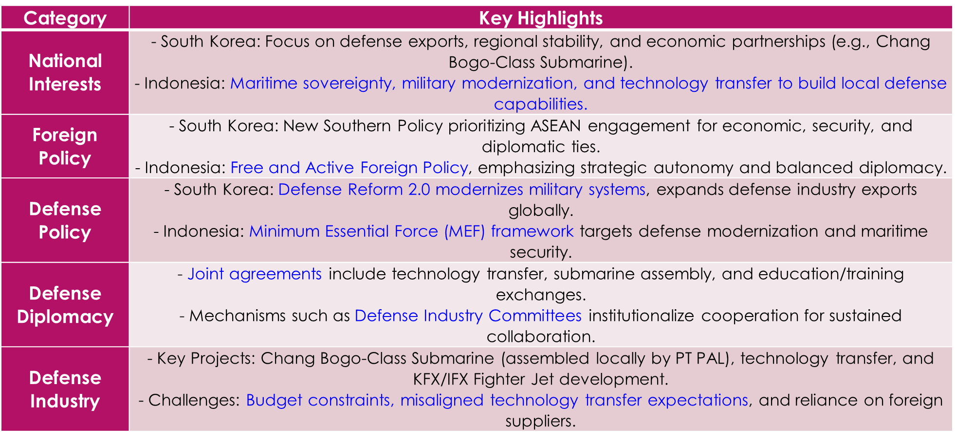
Fig. 3 The informants' data collection results

3.2 Interviews data collection results
highlighted key challenges and opportunities in the Chang Bogo-Class Submarine Project and South Korea-Indonesia defense cooperation. Operational challenges included technical issues in propulsion, electrical, and electronic systems, affecting submarine performance (Navy). Batch-II delays were attributed to unresolved technical problems and policy adjustments, requiring better project management (MoD).

Policy challenges stemmed from Law 16 of 2012, which mandates localization and technology transfer, but unclear implementation strained cooperation with South Korean firms (MoD). Budget constraints, worsened by the COVID-19 pandemic, further delayed defense projects (Academic).
In training and technology transfer, Indonesia praised South Korea’s training programs, especially in simulators and theoretical education, which improved operational efficiency (Navy). However, technology transfer faced implementation barriers, with South Korea acknowledging the need for better follow-up support (Industry).
Geopolitical factors, including South China Sea tensions and the Russia-Ukraine conflict, influenced Indonesia’s neutral defense strategy and diversification of partnerships (Embassy).
For future cooperation, both nations saw potential in joint R&D, particularly in UAVs and cyber-defense (Industry). Indonesia’s Defend ID initiative could enhance local production and technology transfer, supporting long-term defense cooperation (Expert).

3.3 Challenges in the Chang Bogo-Class Submarine Project
The Chang Bogo-Class Submarine Project progressed in two phases. Batch-I (2011-2021) was marked by the successful assembly of submarines at PT PAL and effective technology transfer. Minimal delays occurred due to stable financial planning and efficient project management, strengthening trust between South Korea and Indonesia while enhancing Indonesia’s local shipbuilding capabilities.
In contrast, Batch-II (2019-Present) faced significant delays due to financial constraints, logistical hurdles, and differing expectations on technology transfer. Despite efforts to increase localization, progress was limited, and the project encountered challenges in meeting Indonesia's industrial expectations.

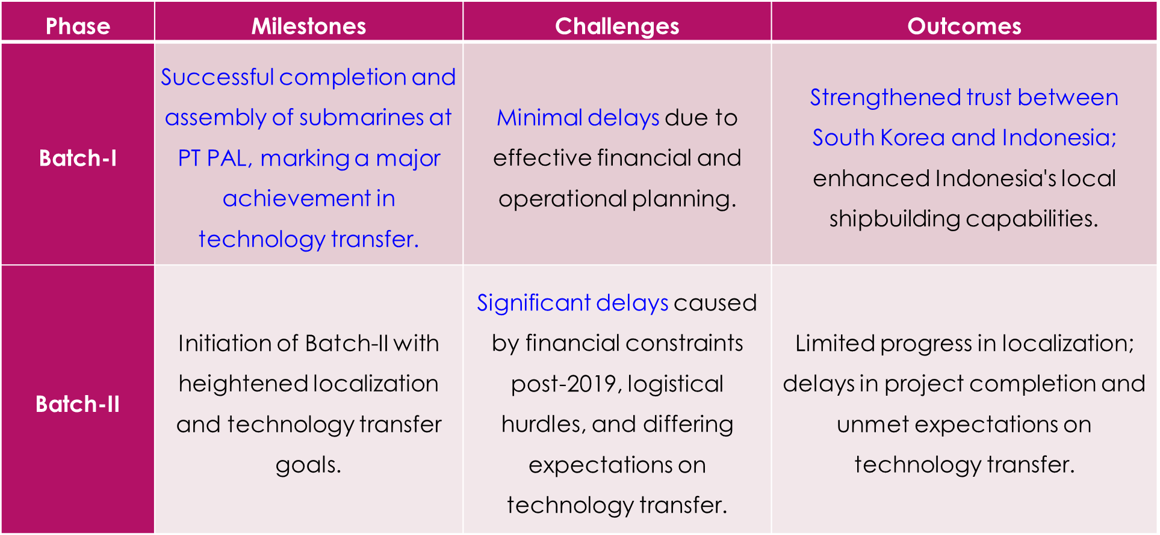
Fig. 4 Batch-I vs Batch-II

3.4 Data Processing Results
The data processing results compare the SBY Administration (2004–2014) and the Jokowi Administration (2014–2024) in their approach to defense cooperation and modernization.

During SBY's tenure, Indonesia focused on military modernization under the MEF framework, strengthening defense ties with South Korea through the 2006 Strategic Partnership. The stable economic environment enabled successful execution of Batch-I of the Chang Bogo-Class Submarine Project, with strong technology transfer and smooth collaboration.
Under Jokowi’s administration, priorities shifted toward domestic infrastructure and economic reform, leading to budget constraints that delayed Batch-II and the KFX/IFX fighter jet project. Indonesia also diversified its defense partnerships, reducing reliance on South Korea by engaging with France and China. Tensions over technology transfer and South Korea’s increased focus on other markets like Poland and the Philippines further challenged Batch-II’s progress.
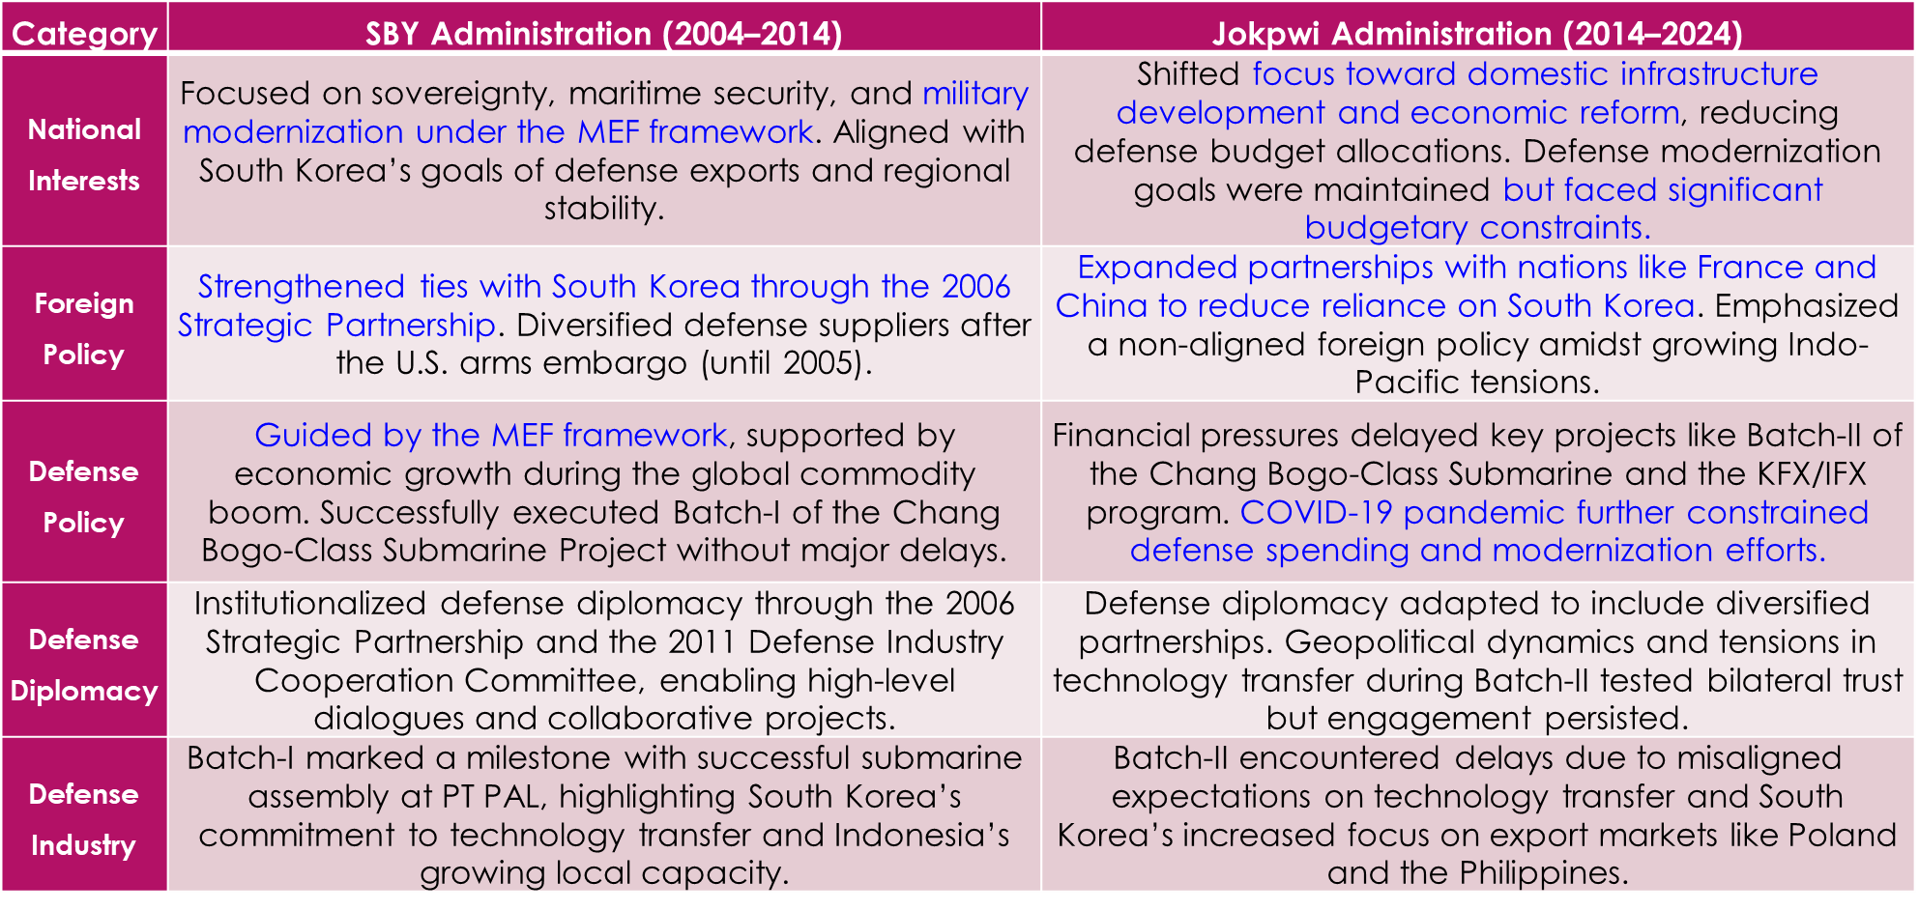
Fig. 5 Data Processing Results

DISCUSSION
A. The Influence of South Korea-Indonesia Defense Diplomacy Shifts (2019–2023) on the Chang Bogo-Class Submarine Project
The shift in South Korea-Indonesia defense diplomacy from 2019 to 2023 had a significant impact on their defense industrial cooperation, particularly the Chang Bogo-Class Submarine Project. One major factor was Indonesia’s shifting defense priorities after 2019, heavily influenced by economic constraints due to COVID-19. As Indonesia prioritized economic recovery, defense budgets were reduced, which delayed the progress of Batch-II of the Chang Bogo-Class submarines. To balance its defense needs, Indonesia diversified its partnerships, engaging with France, China, and other countries, which resulted in a reduced dependence on South Korea. Meanwhile, South Korea shifted its focus toward defense exports, catering to countries like Poland and Ukraine, which had urgent military demands. This strategic divergence slowed the pace of cooperation between the two nations.
Another key issue was technology transfer and localization challenges. South Korea and Indonesia had different perspectives on technology transfer—Indonesia sought full localization to strengthen its domestic defense industry, while South Korea preferred a phased approach that maintained its technological edge. However, Indonesia’s defense infrastructure and local expertise were not yet fully developed to handle large-scale submarine localization, creating further delays and misalignments in the project.
B. The Implementation of Defense Diplomacy to Address Challenges in the Chang Bogo-Class Submarine Project
To address these challenges, South Korea and Indonesia engaged in diplomatic efforts through various high-level defense dialogues and strategic initiatives. Presidential and ministerial-level meetings played a crucial role in maintaining cooperation, with key discussions focusing on project delays, financial constraints, and technology transfer disputes. The Defense Industry Cooperation Committee (DICC) became an essential platform for negotiating solutions and ensuring continued collaboration.
As part of adaptive diplomacy in project management, both nations explored alternative solutions to mitigate budget issues. Flexible payment structures and alternative procurement models were considered to keep the project moving forward. Additionally, technology transfer was implemented gradually, allowing Indonesia to build its defense industry capacity over time rather than executing an immediate full transfer.
Despite these obstacles, strategic alignment remained a core focus of both countries. The Chang Bogo-Class Submarine Project was integrated into broader Indo-Pacific security objectives, reinforcing the long-term vision for bilateral defense cooperation. While short-term budgetary and policy hurdles slowed progress, South Korea and Indonesia remained committed to their shared security interests and the continued development of defense industrial cooperation.

CONCLUSION
This study comprehensively analyzed the evolving dynamics of South Korea-Indonesia defense diplomacy, with a particular focus on the Chang Bogo-Class Submarine Project during the 2019–2023 period. The research findings indicate that shifts in bilateral relations were driven by changing national priorities, economic constraints, and geopolitical developments. By examining key diplomatic initiatives, challenges in technology transfer, and institutional mechanisms, the study provided a holistic understanding of how national interests and international collaboration intersect within the broader context of Indo-Pacific security.
Addressing Research Problem 1—which examines how shifts in government priorities impact defense cooperation and naval modernization—the study revealed that while the Yudhoyono administration established a robust foundation for defense collaboration through strong financial backing, strategic defense agreements, and successful technology transfer during Batch-I, the Jokowi administration’s focus on domestic infrastructure and economic resilience—compounded by COVID-19 financial pressures—resulted in delays and renegotiations in Batch-II, ultimately affecting Indonesia’s naval modernization efforts.
In addressing Research Problem 2—which explores the role of defense diplomacy in sustaining bilateral cooperation amid project uncertainties—the study demonstrated that South Korea and Indonesia effectively leveraged defense diplomacy, with the Defense Industry Cooperation Committee (DICC) playing a pivotal role in facilitating negotiations, resolving financial constraints, and aligning technology transfer expectations, while joint military training and interoperability initiatives further reinforced resilient defense relations.
A significant challenge identified was the ongoing tensions surrounding technology transfer and localization goals. While Batch-I demonstrated Indonesia’s capacity for local assembly, Batch-II faced setbacks due to conflicting expectations—South Korea’s concerns over intellectual property protection versus Indonesia’s ambition for full localization. This underscores the need for structured, phased technology transfer agreements with well-defined operational frameworks to minimize misunderstandings and align long-term objectives.
Despite these challenges, both nations reaffirmed their commitment to strengthening defense ties, recognizing the strategic importance of the Chang Bogo-Class Submarine Project in Indonesia’s Minimum Essential Force (MEF) framework and South Korea’s defense export strategy. Moving forward, the success of bilateral defense industrial cooperation will depend on financial sustainability, adaptive diplomacy, and clear commitments to structured technology transfer.
In conclusion, the Chang Bogo-Class Submarine Project encapsulates both the strengths and vulnerabilities of South Korea-Indonesia defense cooperation. The study highlights the importance of institutionalized defense diplomacy, resilient financial frameworks, and transparent agreements to sustain long-term collaboration. While economic constraints, geopolitical pressures, and technology transfer challenges posed significant hurdles, they did not weaken the strategic commitment of both nations to fostering a stable and secure Indo-Pacific region. This case study provides valuable lessons for future bilateral defense initiatives, emphasizing the need for adaptive strategies, enhanced financial planning, and deeper institutional integration to navigate evolving security challenges successfully.

REFERENCES
Art, R. J. (1991). A Grand Strategy for America. Cornell University Press.
Brown, C., & Ainley, K. (2005). Understanding International Relations (3rd ed.). Palgrave Macmillan.
Keohane, R. O., & Nye, J. S. (1977). Power and Interdependence: World Politics in Transition. Little, Brown.
Perwita, A. A. B., Gusmiarti, A. D., Hashmi, H. R., & Mahroza, J. (2022). Defense diplomacy for capacity building: A conceptual approach through case studies. Republic of Indonesia Defense University Press.
Perwita, A. A. B., Pertiwi, A. D., Pramono, B., & Rossiana, Y. S. (2022). Defense diplomacy for confidence building measures. Universitas Pertahanan RI.
Perwita, A. A. B., & Yani, Y. M. (2021). Pengantar Ilmu Hubungan Internasional. PT Remaja Rosdakarya.
Smith, S., Hadfield, A., & Dunne, T. (2008). Foreign Policy: Theories, Actors, Cases. Oxford University Press.
Wendt, A. (1999). Social Theory of International Politics. Cambridge University Press.
Theses
Tamarell Vimy Salsa Bila, Widodo, Bayu Asih Yulianto. (2023). Policy Review of the Effectiveness of the Submarine Technology Transfer Roadmap between Indonesia and South Korea. Republic of Indonesia Defense University.
Ahmad, M. (2021). Research Methods for Political Science: Quantitative and Qualitative Approaches. Oxford University Press.
Anwar, D. F. (2010). The Impact of Domestic and Asian Regional Changes on Indonesian Foreign Policy. Southeast Asian Affairs, 2010(1), 126-141.
Braun, V., & Clarke, V. (2006). Using thematic analysis in psychology. Qualitative Research in Psychology, 3(2), 77-101.
Caverley, J. D. (2007). The Myth of Military Myopia: Democracy, Small Wars, and Vietnam. International Security, 32(3), 119-157.
Chang, Y. S. (2020). The Strategic Implications of Indonesia's Defense Diplomacy. Asian Survey, 60(5), 903-925. https://doi.org/10.1525/AS.2020.60.5.903
Creswell, J. W., & Poth, C. N. (2018). Qualitative Inquiry and Research Design: Choosing Among Five Approaches (4th ed.). SAGE Publications.
Denzin, N. K., & Lincoln, Y. S. (Eds.). (2017). The SAGE Handbook of Qualitative Research (5th ed.). SAGE Publications.
Dunne, J. P., & Perlo-Freeman, S. (2003). The Demand for Military Spending in Developing Countries. International Review of Applied Economics, 17(1), 23-48.
Finnin, M. (2022). Qualitative Research Methods: An Overview. Routledge.
Gansler, J. S. (1980). The Defense Industry. MIT Press.
Inkiriwang, F. W. (2020). The dynamic of the US–Indonesia defence relations: the ‘IMET ban’ period. Australian Journal of International Affairs, 74(4), 377–393. https://doi.org/10.1080/10357718.2020.1712327
Jeon, I., & Yuwanto, Y. (2014). Indonesia's Defense Diplomacy: Transformation Under President Yudhoyono and Beyond. Defence and Security Analysis, 30(3), 268-282. https://doi.org/10.1080/14751798.2014.942627
Kim, T. H. (2012). The Evolution of South Korea-Indonesia Defense Relations. Journal of East Asian Affairs, 26(2), 117-140.
Manafe, Y., Swastanto, A., & Pedrason, R. (2020). Defense Industrial Cooperation between Indonesia and South Korea: An Analysis of Strategic Partnership. Journal of International Defense Relations, 12(4), 321-350.
Defence Ministry of The Republic of Indonesia. (2015). Indonesia Defence White Paper.
Defence Ministry of The Republic of Indonesia. (2021). General Policy of National Defense for 2020-2024.
Lemhannas RI. (2010). Grand Design Minimum Essential Force (MEF) 2010-2024. National Resilience Institute of Indonesia.
ASPI Strategist. (2022). South Korea is Still Indonesia’s Best Partner for Defense Technology Cooperation. Retrieved from https://www.aspistrategist.org.au
Brockhaus-Enzyklopädie. (1967). Brockhaus-Enzyklopädie. F.A. Brockhaus.
Korea Herald. (2023). Yoon, Widodo Agree to Deepen Economic and Defense Ties. Retrieved from https://www.koreaherald.com
Lockheed Martin. (2021). T-50 Golden Eagle Program Overview. Retrieved from Lockheed Martin's official website.
Ministry of Defense. (2015). Defense White Paper. Retrieved from Ministry of Defense website.
SIPRI. (2024). SIPRI Arms Transfers Database. Retrieved from https://www.sipri.org/databases/armstransfers

S. Dostoglou, S.: On the asymptotics of the finite energy solutions of the Yang-Mills-Higgs equations, Journal of Mathematical Physics, 31, 2490-2496 (1990).
S. Carstensen, E.P. Stephan, Adaptive boundary-element methods for transmissions problems, Journal of Mathematical Analysis and Applications, 106, 367-413 (1985).
C.P. Bruter, Mathematics and Art, Springer, Paris, 2002.
N. Lesmoir-Gordon, M, Frame, B. Mandelbrot, N. Neger, Mandelbrot's World of Fractals, Key Curriculum Press, 2005.
Korb, K. B. & Nicholson, A.E. (2011). Bayesian Artificial Intelligence. 2nd Edition. CRC Press: Boca Raton.

